**Chapter 1 Managerial Accounting**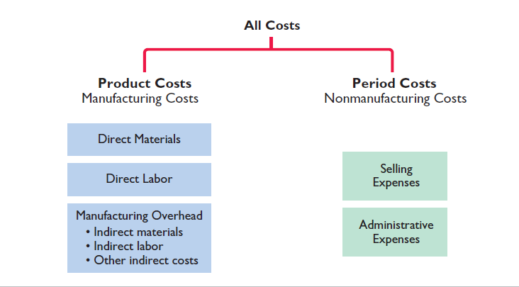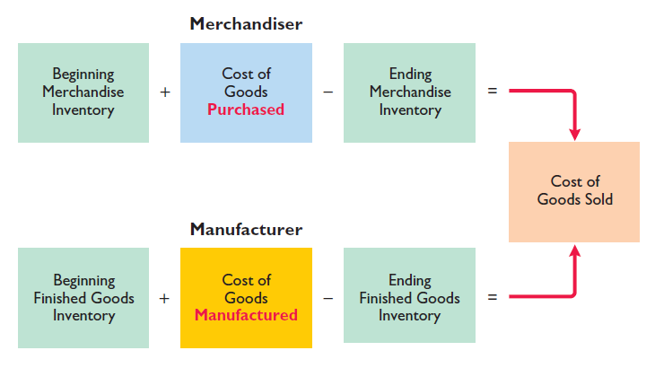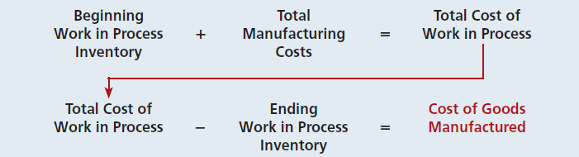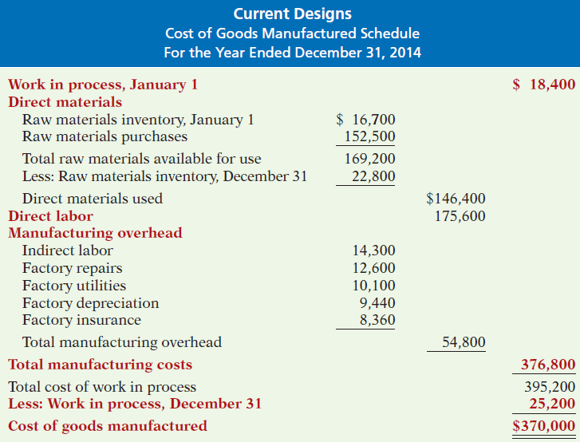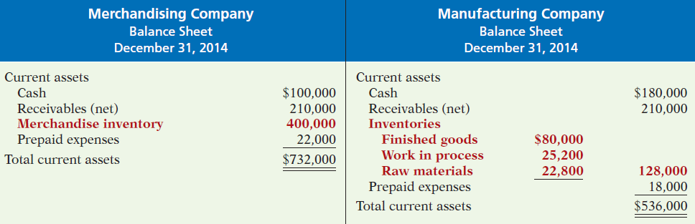

E1-2 Presented below is a list of costs and expenses usually incurred by Barnum Corporation, a manufacturer of furniture, in its factory.

1. Salaries for assembly line inspectors.

2. Insurance on factory machines.

3. Property taxes on the factory building.

4. Factory repairs.

5. Upholstery used in manufacturing furniture.

6. Wages paid to assembly line workers.

7. Factory machinery depreciation.

8. Glue, nails, paint, and other small parts used in production.

9. Factory supervisors’ salaries.

10. Wood used in manufacturing furniture.

***Instructions***

Classify the above items into the following categories: (a) direct materials, (b) direct labor, and (c) manufacturing overhead.

E1-5 Ikerd Company is a manufacturer of personal computers. Various costs and expenses associated with its operations are as follows.

1. Property taxes on the factory building.

2. Production superintendents’ salaries.

3. Memory boards and chips used in assembling computers.

4. Depreciation on the factory equipment.

5. Salaries for assembly-line quality control inspectors.

6. Sales commissions paid to sell personal computers.

7. Electrical components used in assembling computers.

8. Wages of workers assembling personal computers.

9. Soldering materials used on factory assembly lines.

10. Salaries for the night security guards for the factory building.

The company intends to classify these costs and expenses into the following categories:

(a) direct materials, (b) direct labor, (c) manufacturing overhead, and (d) period costs.

***Instructions***

List the items (1) through (10). For each item, indicate the cost category to which it belongs.

